CHAPTER 3 : ANALYSIS AND DESIGN

**3.1 DFD**

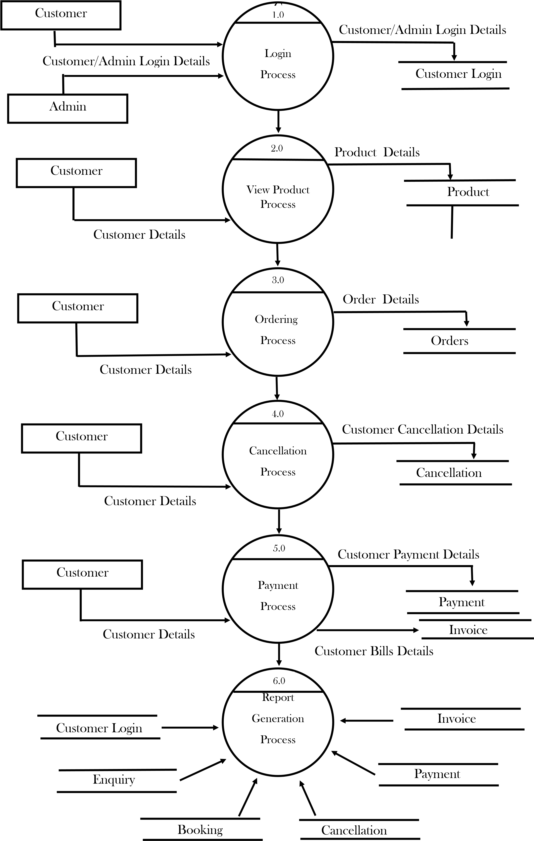

3.2 TABLE SPECIFICATION ( DATABASE )

TABLE NAME : CUSTOMER LOGIN

|  |  |  |  |  |
| --- | --- | --- | --- | --- |
| SR.NO. | DATA NAME | DATA DISCRIPTION | ALIASIS | LENGTH |
| 1 | cname | Name of the customer | Enter customer name | Varchar  30 |
| 2 | cpassword | Id of the customer | Enter customer id | Int 10 |
| 3 | ccontact | Mobile number of customer | Enter customer number | Int 10 |

TABLE NAME : DRESS ORDERING

|  |  |  |  |  |
| --- | --- | --- | --- | --- |
| SR.NO. | DATA NAME | DATA DISCRIPTION | ALIASIS | LENGTH |
| 1 | name | Name of customer | Enter customer name | Varchar  20 |
| 2 | address | address of  customer | Enter customer address | Varchar  30 |
| 3 | gender | gender of  customer | Enter customer gender | Varchar  10 |
| 4 | state | State of customer | Enter customer state | Varchar  20 |
| 5 | email | email of customer | Enter customer email | Varchar  20 |
| 6 | phone no. | Contact of customer | Enter customer contact | Int 10 |
| 7 | Nationality | nationality of  customer | Enter nationality of customer | Varchar  20 |
| 8 | product | Check product id of the  customer | Enter product id of customer | Int 10 |
| 9 | product | Check  ProductNameof the | Enter product name of customer | Varchar  20 |
|  |  | Customer |  |  |
| 10 | product | Check product brand of the  customer | Enter name of the brand of customer’ s product | Varchar  50 |
| 11 | product | Check category of the product | Enter check out time of customer | Int 6 |
| 12 | product | Check product description | Enter description of the product | Int 100 |
| 13 | product | Check QuantityInStock | Enter no of products available | Int 20 |

TABLE NAME : OWNER

|  |  |  |  |  |
| --- | --- | --- | --- | --- |
| SR.NO. | DATA NAME | DATA DISCRIPTION | ALIASIS | LENGTH |
| 1 | oname | Name of owner | Enter owner name | Varchar  20 |
| 2 | oid | Id of owner | Enter owner id | Int 10 |
| 3 | oemail | Email of owner | Enter owner email | Varchar  10 |
| 4 | oaddr | Address of owner | Enter owner address | Varchar  30 |
| 5 | ocontact | Mobile number of owner | Enter owner contact | Int 10 |

TABLE NAME : PAYMENT

|  |  |  |  |  |
| --- | --- | --- | --- | --- |
| SR.NO. | DATA NAME | DATA DISCRIPTION | ALIASIS | LENGTH |
| 1 | cname | Name of customer | Enter customer name | Varchar  20 |
| 2 | ccontact | Id of customer | Enter customer contact | Int 10 |
| 3 | cemail | Email of customer | Enter customer email | Varchar  10 |
| 4 | ccard | Card type of customer | Enter card type of customer | Varchar  10 |
| 5 | Ccard no. | card number of customer | Enter card no. of customer | Int 16 |
| 6 | Amount | Amount of customer | Enter amount of customer | Int 100 |

TABLE NAME : EMPLOYEE

|  |  |  |  |  |
| --- | --- | --- | --- | --- |
| SR.NO. | DATA NAME | DATA DISCRIPTION | ALIASIS | LENGTH |
| 1 | ename | Name of employee | Enter employee name | Varchar  20 |
| 2 | eid | Id of employee | Enter employee id | Int 10 |
| 3 | eemail | Email of employee | Enter employee email | Varchar  10 |
| 4 | eaddr | Address of employee | Enter employee address | Varchar  30 |
| 5 | econtact | Mobile number of employee | Enter employees contact | Int 10 |

3.3 ERD

Payment

Customer

Boutique

Products

has

Order

Done

by

Ptype

Bno

Bname

B

_Id

Pprice

P

name

Cname

Cnumber

Pid

online

offline

Adds

Admin

Aid

Aname

Apassword

3.4 OBJECT DIAGRAM

Customer Order Product

customerID: C001 orderID: O1001 productID: P101

name: "John Doe" 1 * orderDate: 2024-11-25 * 1 name: "Red Dress"

email: "john.doe@... 1 * status: "Shipped" description: "Stylish

<------------------

<-------------------------

address: "123 Main..." totalAmount: 150.00 price: 100.00

phone: "555-1234" customerID: C001 stockQuantity: 50

1 1 1

Payment Inventory Employee

paymentID: PAY1001 productID: P101 employeeID: E001

paymentDate: 2024-11-25 stockQuantity: 50 name: "Alice Smith"

amount: 150.00 restockDate: 2024-12-01 role: "Cashier"

paymentMethod: "Credit Card email: "alice@ex...

status: "Completed

orderID: O1001

3.5 CLASS DIAGRAM

Customer Order OrderItem

<>---------------------

<>---------------------

customer_id order_id order_item_id

name order_date product_id

email total_amount quantity

price

Product

product_id

name

price

Payment

payment_id

amount

payment_date

payment_method

3.6 USE CASE DIAGRAM

Boutique

Admin

Costumer

Generate Report

Add Product

Place Order

Make Payment

Update Inventory

Remove Product